There is an issue when you minimize the page, I used Firefox and you see the search bar moves and cover the logo plus the whole moves giving huge spacing . The Structure or architecture of the site may not be strong. Also is the website mobile friendly because the layout changes when viewed on tablets.

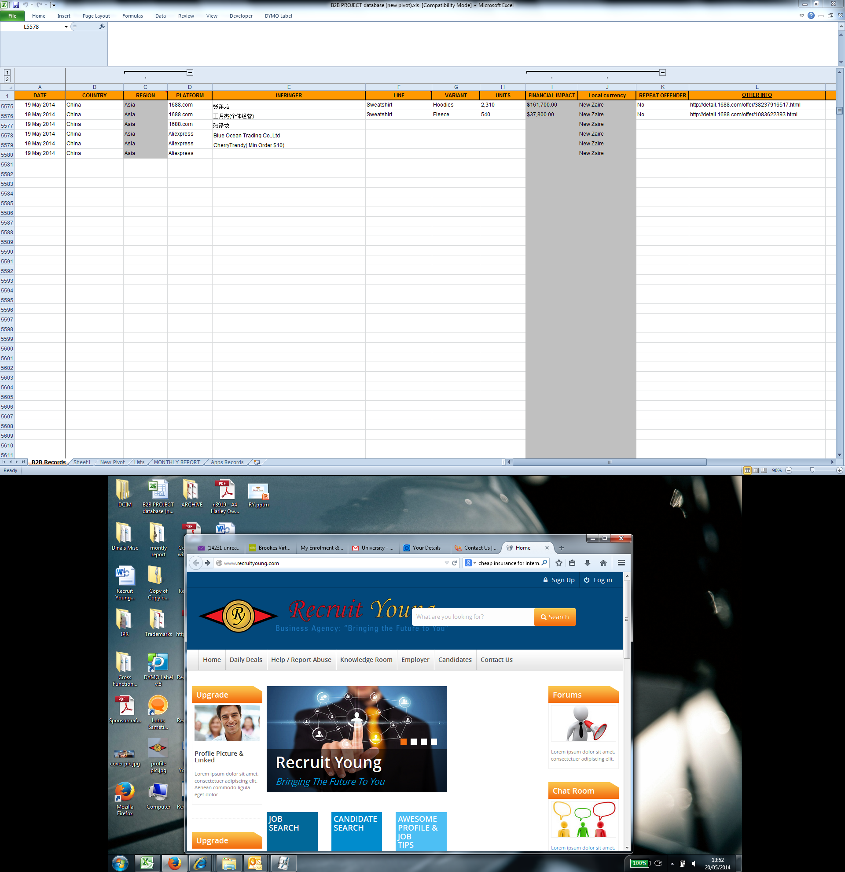

This showed up after making using the general search for David’s page and you can see the issues caused on this page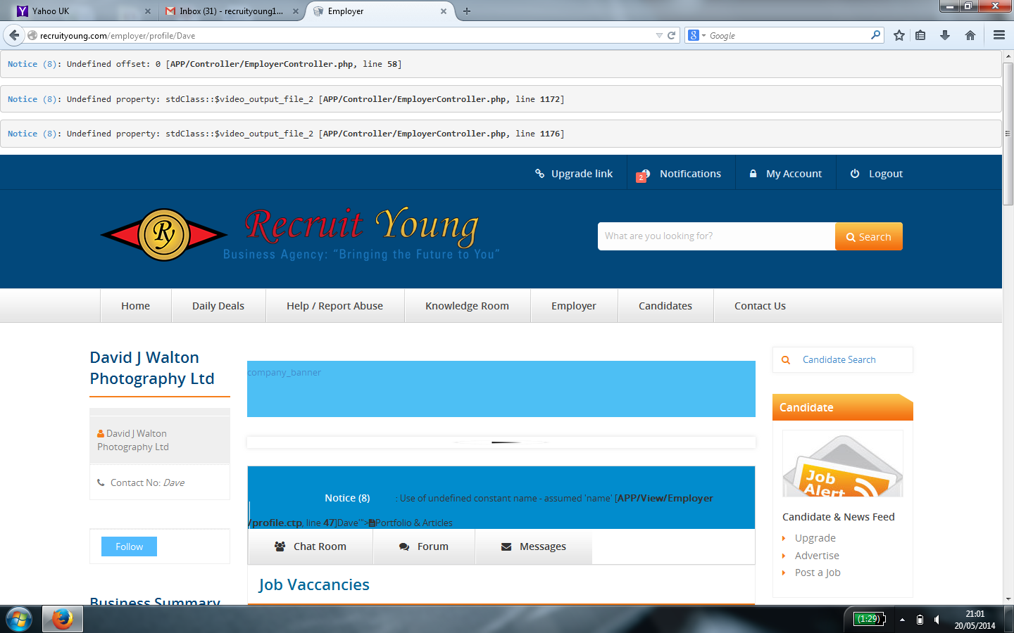

Upgrade and upgrade link for employers missing the membership upgrade for employers

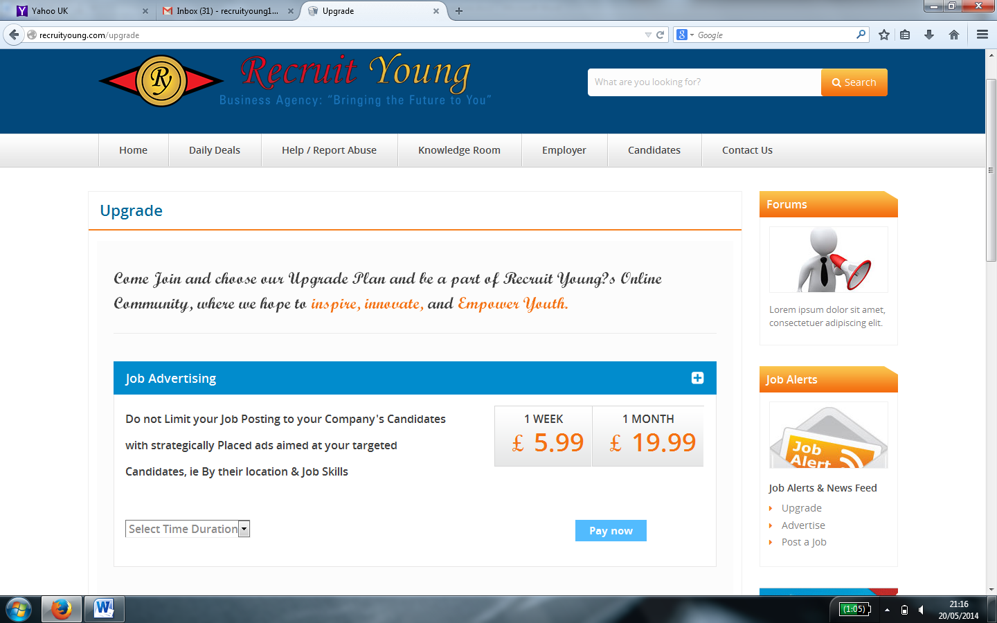

Contact page error for invalid email

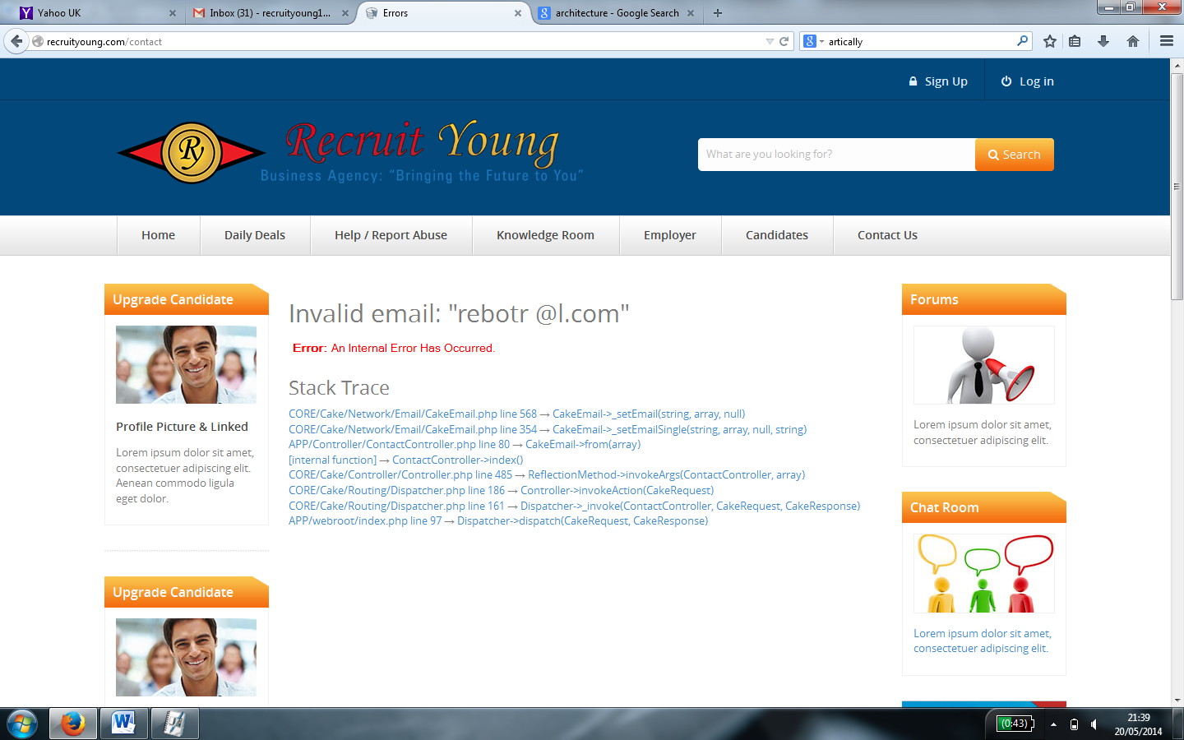

The forum page has no header or footer or login options

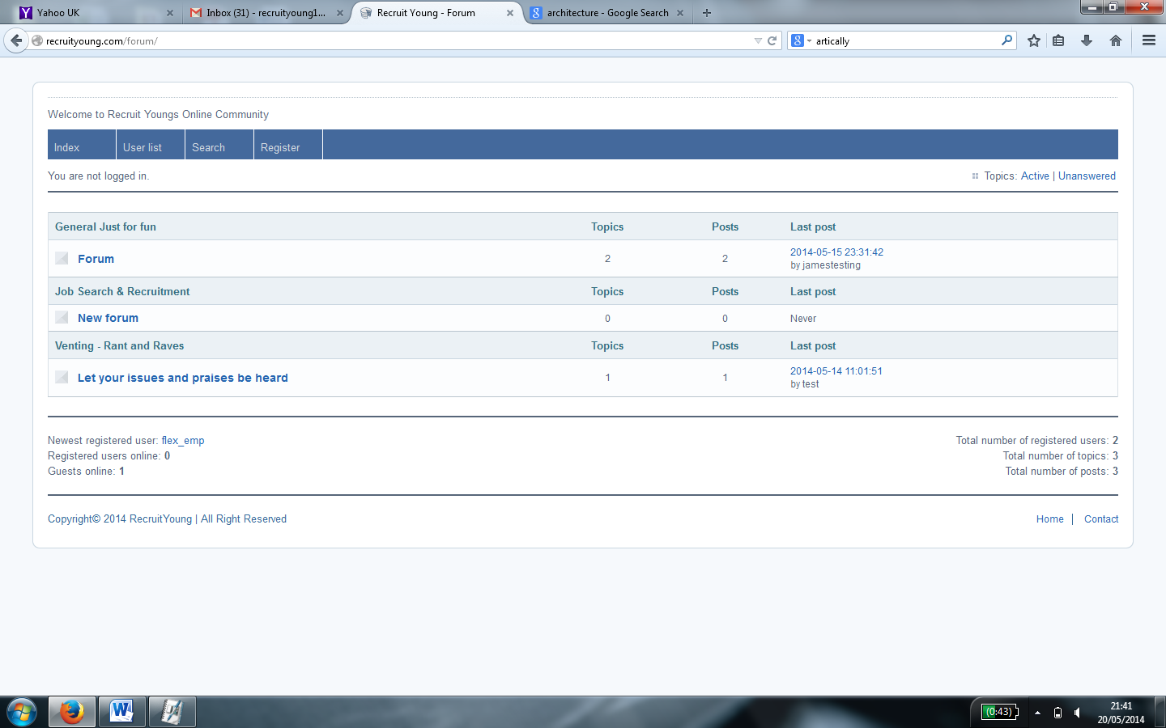

The login page is saying - <http://alpha.cisinlabs.com:81/cakejobportal/users/login> after I logged out of user employer@mailinator.com

Please ensure the whole site is listed http://recruityoung.com

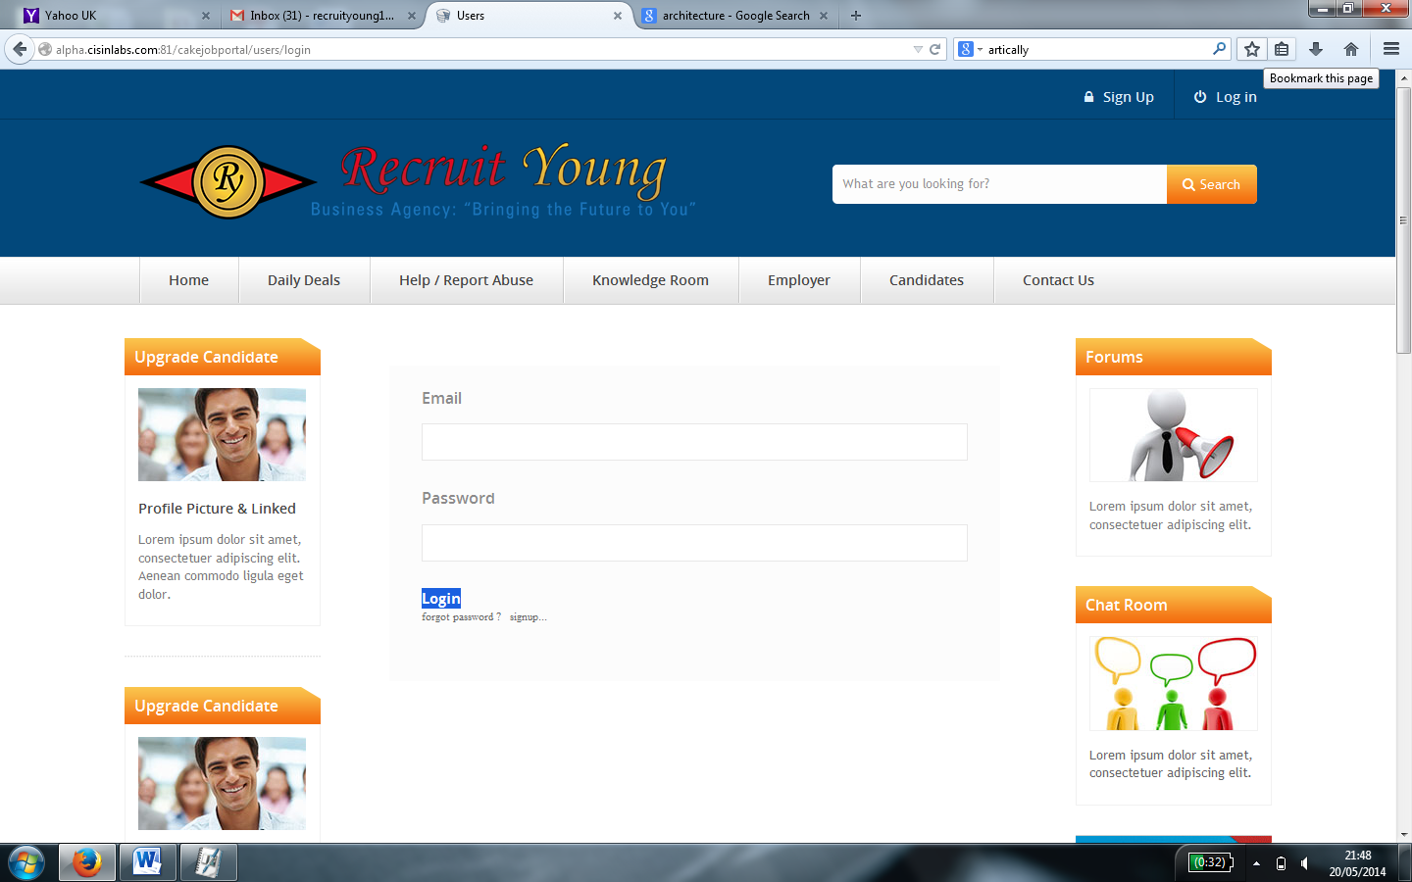

The chat room should be for members only and at the moment it is open to anyone . there is no sign in option or login for the chat room

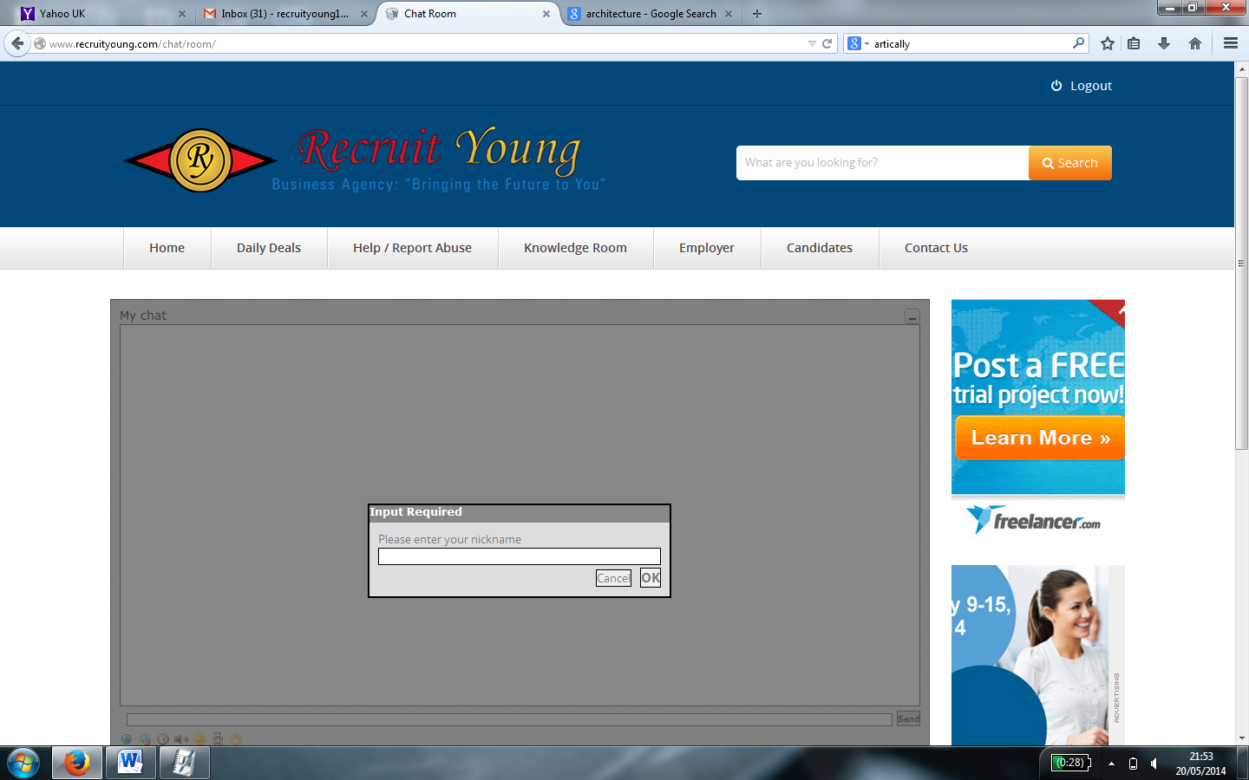

Does this when the screen is minimise

